Game Design Document  
The Secret Museum

**Overview**

**Product Details**

* Players
  + Single Player
* Genre
  + Isometric, 3rd Person, Adventure RPG
* Platform
  + PC/Switch
* Outlets
  + Steam, Nintendo Store, Epic

**Summary**

Casual RPG, play as Jen, an unassuming character who stumbles on a secret museum tasked with collecting legendary items based on folk tales that are lost thought the world (John Henry’s Hammer, Paul Bunyan’s Axe, and Johnny Appleseed’s seed bag as examples)

**Pillars**

* RPG
* Folk tale characters
* Item Collection

**Unique Selling Points**

* Low poly art style (current strong trend in games to have low poly art)
* Interaction and learning of folk tales and the key characters

**Target Market**

* Casual Players
* Players that enjoy a narrative based game with RPG elements

**Game Loops**

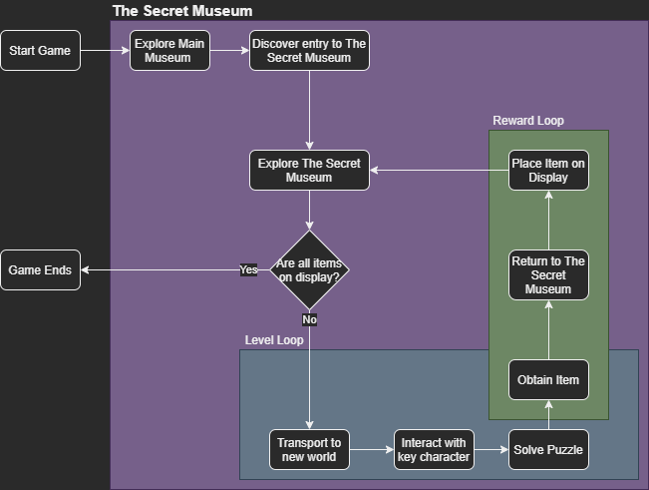

**Mechanics**

* Movement & Camera
  + **On PC; It is a point and click movement and WASD for camera control**
  + **On Switch; The right joypad is used for movement and left joypad for camera**
* Puzzles
  + Thematic puzzles catering to each key character (challenge/obstacles)
  + Drag and use items in the inventory to solve puzzles by interacting with key points (drag knife to apple, player cuts apple)
* Museum Display
  + Players collected item is put on a display in The Secret Museum as an exhibition and the area is lit up and interacting with the display will display information and tale about the item
* Teleporting
  + Each empty display with a title plaque can transport the player to a new level belonging to a key character related to the plaque information

**Controls**

* PC
  + Keyboard: WASD for camera control and they will rotate and arch over the player
  + Mouse: Click left mouse button to indicate where the player will go, Right mouse click to pick up items, Middle mouse hold to pan the camera, scroll wheel to zoom in/out
* Switch
  + R1 to Zoom in, Z1 to Zoom out, Left joystick is camera control, and right joystick is player movement control

**Key Characters**

* The player will encounter characters from folklore, and they will task the player with a challenge to complete (in the form of a puzzle)
  + John Henry’s Challenge: Use his hammer to hammer down as many nails and as fast as possible on a railway track
  + Johnny Appleseed’s Challenge: Plant as many seeds using Johnny’s seed bag with in a period of time to win this challenege

**Player Progression**

The Secret Museum has many Rooms/Wings/Exhibition areas that are unlit/dark/unkempt, each time a player completes a challenge, the player returns with the item, the room lights up and looks new